[Type the document title]

[Type the document subtitle]

[Type the abstract of the document here. The abstract is typically a short summary of the contents of the document. Type the abstract of the document here. The abstract is typically a short summary of the contents of the document.]

2012

Mandal, Kaniska

Dell Inc

1/1/2012

# Table Of Content

# System Synopsis :

# Design Overview :

## Cloud Foundry Design Overview :

## Web App Design Overview :

### Flow Diagram :

### Web App Anatomy :

**Implementaion Details :**

## Adopting Cutting Edge Technologies :

## Low-Latency High-Performance :

## Code Snippets and Working Logic :

**Demo Screnshots :**

**Future Scope :**

# System Synopsis :

Cloud Computing Innovations fostering Rapid Application Development and promoting fast release and automatic management of products.

There exist many interesting Cloud Suites that offer End2End solutions from coding on cloud, automatic resource allocation, database instance creation to build/package/deploy and also auto-scale based on resource consumption, routing across machines based load, auto failover and monitoring capabilities.

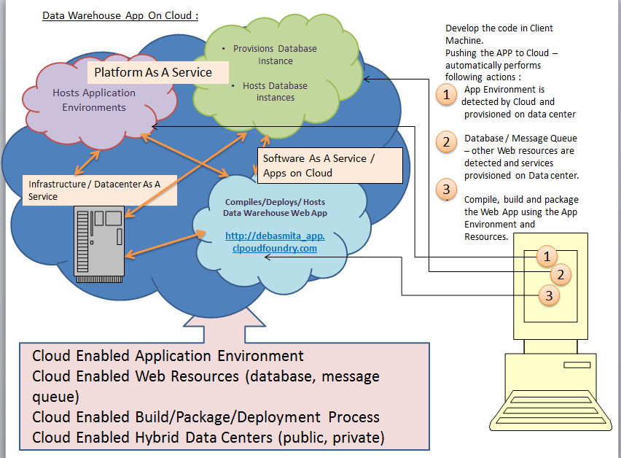

We venture out in the beautiful world of VMWare Cloud Foundry (CF) which is one of the best ‘Reference Architecture and Implementation’ of Cloud-Enabled Application Platforms.

We start with a simple code, push it to the CF Cloud through the command shell – VMWare Cloud Controller (VMC).

CF automatically detects the type of Application and allocates the Database Resources.

CF automatically provisions the services (proviing resource and data connectivity).

That way we iteratively build the application just by pushing the app again to Cloud.

# Design Overview :

## Cloud Foundry Design Overview :

## Web App Design Overview :

DATA ACQUISITION

Business Data is updated in the Source Repository (Business Data Source -> can take the form of File System / Database ).

The Server listens to the changes in the Source repository through a Pub/Sub Queue .

DATA EXTRACTION & LOADING

As soon as Server receives data from a Business DataSource,

* it extracts the records from the DataSource and loads the data in a staging table of a high-performance database for future queries on detail information.

DATA ANALYSIS & WAREHOUSE

The Server instantly calculates the Sum/Avg/Count in the database in a separate aggregation table.

DATA VISUALIZATION & REAL-TIME ANALYTICS

The Bowser opens a persistent or long-lasting HTTP connection with the Server through Socket I/O

* browser instantly is updated with the data.
* Browser can send request to the Server to show the pre-computed Sum/Avg/Count
  + This ensures very fast analytics result.

APPLICATION SCALABILITY

APPLICATION AVAILIBILITY

RAPID APPLICATION DEVELOPMENT

### Flow Diagram :

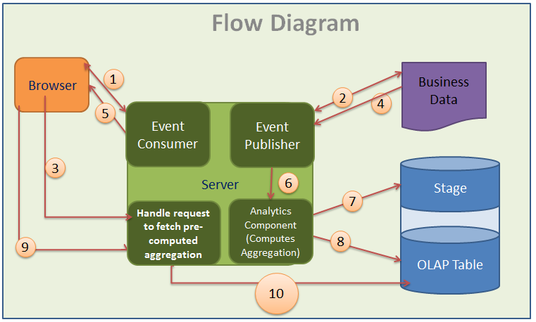

1.

The most imporatant aspect of ‘Real Time Analytics’ is – Polling a Web Server.

Here we fetch the data and update the UI without refresing the whole webpage.

We adopted LONG POLLING ([long-held HTTP request](http://en.wikipedia.org/wiki/Comet_%28programming%29)) -- the best and most efficient Server-Push Technique.

As you can see, the Long Polling technique combines the best-case traditional polling with persistent remote server connections.

2.

3.

4.

5.

6.

7.

8.

9.

10.

### Web App Anatomy :